Waskowitz Outdoor School Open House
9/22/19 from 12:30-2:30

9/4/2019

Dear Families,

Your child is scheduled to attend Waskowitz Outdoor School for a week in the 2019-2020 school year, perhaps you would like to see the facility before sending your child. We will be hosting an Open House on Sunday September 22, 2019 from 12:30 PM to 2:30 PM. We would like to have your family as our guest. Sweatshirts and T-shirts will be available at this time to purchase, please bring cash or checks.

Due to space limitations and full programming during the week of your child’s stay, we are unable to provide you with any formal visiting time with your child. Therefore, Open House is an ideal way to get acquainted with the facility and to familiarize yourself with the variety of educational opportunities your child will be involved in. You will also be able to view the cabins where the students sleep. Our Outdoor School Nurse will be available to answer questions and address concerns you many have. In addition, you will have access to a binder that we have created to inform you of the ingredients in the foods we serve at outdoor school for your dietary concerns.

Waskowitz is a comfortable hour drive from your home. It is located ¾ miles east of North Bend along Interstate 90. The address 45505 SE 150th ST, North Bend, WA 98045.

Driving directions: Traveling eastbound in I-90, take exit #34 (468th Ave). At the stop sign, turn right onto 468th Ave SW. Take the first right onto SE 150th. Continue on SE 150th for ¾ mile to the Waskowitz Education Center.

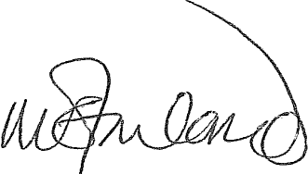
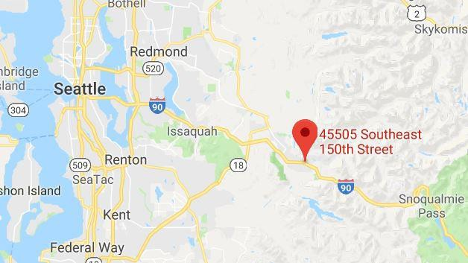
Sincerely,

Dr. Roberta McFarland, Director/Principal Waskowitz Outdoor School

